Katie Ericson
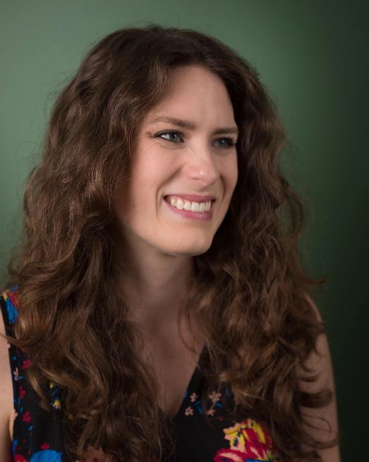
I have worked in art education in museums over the past six years at the North Carolina Museum of Art (NCMA), Bernard A. Zuckerman Museum of Art (ZMA) at Kennesaw State University, and the Michael C. Carlos Museum at Emory University. I have a BS in Art Management from Appalachian State University and an MA in Art Education from the University of Florida. Much of my work in art museums has consisted of creating and fostering connections with art, through STEAM, history, movement, language arts, and more - I am always looking for ways to emphasize the universality of art across time and disciplines. I am currently the Senior Manager for School and Volunteer Support Programs at the Carlos Museum where I develop professional learning opportunities and curriculum materials for K-12 educators based around our exhibitions and collections. I also develop new thematic tours, and train our volunteers on content and museum pedagogy for people of all ages. One new initiative that I have been working on at the Carlos has been the creation of our new Teacher Advisory Council. Comprised of 21 educators from public and private schools, from over 11 districts. An important part of the selection process was to create a council that was reflective of our community. We wanted diverse opinions, teachers across all disciplines and grade levels, and teachers who have previously participated with the museum as well as those who haven’t. I am interested in identifying barriers that exist for our schools and teachers, and working with the Council to create more opportunities for access. Museums can provide opportunities to tell the stories of the human experience and my interest is looking at how art museums can tell these stories, resist biases and inequalities, and increase accessibility for all to the arts and arts education.

Still fairly new to the state of Georgia, I have not yet had the opportunity to attend GAEA - I plan to attend for the first time in 2019! I have attended NAEA, where I presented with former colleagues and teaching artists from the North Carolina Museum of Art on Pop-Up art making programs, and regularly present on professional and interdisciplinary education at state and regional museum conferences. I hope that moving forward I can participate in a greater capacity with GAEA. I have a deep love and appreciation for connecting with a community that shares my passions, and would love the opportunity to work with art teachers from all over Georgia.

