Kacie Mummert
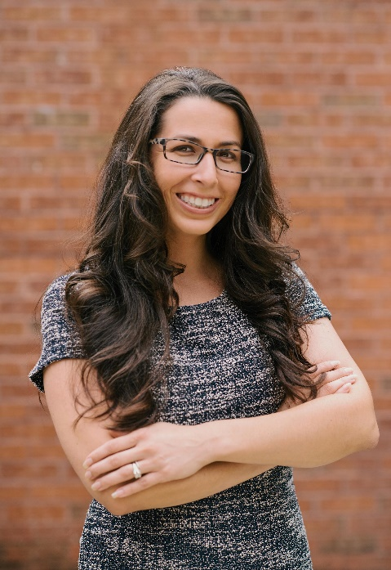
I have been teaching middle school art education for 10 years. In addition to serving as the art teacher at Mabry Middle School, I also serve as the Fine Arts Subject Area Coordinator, yearbook advisor, part of the Technology Think Tank, and on the STEAM board. I often provide professional development opportunities to the Mabry staff, other Cobb art teachers, and at conferences. Outside of the classroom, I have broad experience as a teacher leader, mentoring new teachers, organizing a large sidewalk chalk event, and working as a ceramics instructor.
Community engagement is critical when it comes to students, education, and the arts. At Mabry, I work with PTSA to bring in professional artists as well as college representatives to speak on art careers. I encourage students to participate in various art shows throughout the year. I want students to see their artwork outside the classroom making an impact on the community. I also worked with Kennesaw State University’s Zuckerman Museum of Art to develop Chalk The ZMA, a community sidewalk chalk event.
I have experience in designing content, presenting, and working with teachers to make connections that create rigorous and relevant lessons. I presented at the National Art Education Association conference about designing and piloting the 8th grade visual art comprehensive high school credit class. I have also collaborated with the music, science, technology, and French departments to provide cross-curricular instruction at Mabry.
I have presented at several GAEA & NAEA Conferences. In my presentations I have shared how to develop an advanced 8th grade art class for high school credit. This course allows 8th graders in Cobb county to complete the visual arts comprehensive course they need in high school as a prerequisite for all other art classes. I have also presented various engaging lessons including a one activity that allows students to understand the importance of time when it comes to being creative. This hands on lesson/class discussion allows you to gain a basic assessment of the students skill level while emphasizing how time plays a role in the quality of artwork they produce. It also allows students to discover a level of expectation without the teacher even having to say it. I was also honored to be awarded the 2015 GAEA middle level art educator of the year.

