Jackie Ellett
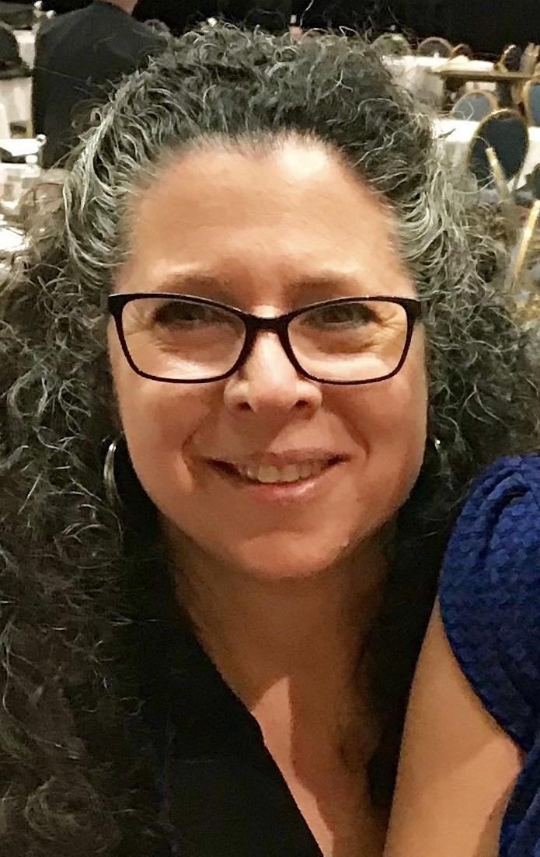
I taught for 32 years in Gwinnett county as an elementary art teacher and first got involved with GAEA in 1987. In 1994 I began teaching as an adjunct professor in art education for what was then called North Georgia College in Dahlonega, GA and have taught for Brenau, Mercer, UGA, and Piedmont College where I have been teaching since 2013. I currently teach full time at Piedmont as Associate Professor of Art Education. I have been involved in all areas of curriculum writing for Gwinnett County, the state of Georgia, Glenco Publishing, SRA McGraw-Hill as well as for exhibits for the High Museum and Brenau University. I worked on the original Georgia Standards, National Standards, and GACE. I was a co-lead elementary art teacher for Gwinnett and have had more than 30 student teachers in my last 20 years of teaching. Because I know how hard teaching is, I have initiated a mentoring program at Piedmont in which I follow and work with those art teachers who are first starting out so that they have continued support through their first year of teaching. I believe in art education and the positive power it has on our children in our schools.
I first became involved with GAEA in 1987 as the GAEA East-Metro Atlanta District President and presented at my first conference. Since this time I have presented most years (1987- 99; 2002-2008; 2010-15), was 2009 State Conference Co-Chair, Brasstown Valley, GA, and in 1992, 94-96 GAEA State Conference Workshop Coordinator. Other areas I have been involved with GAEA are as follows: 1990, 91, 92, 94, 98 GAEA Leadership Workshop; Co-presenter; 1989, 91-93 GAEA Capital Exhibit Chair; 1988,1993-94 GAEA Youth Art Month Chair, 1994-96 GAEA Elementary Division Director; 2012-15 GAEA Member at large; 2017 Initiated and coordinated 1st GAEA regional weekend workshop, Piedmont College, Demorest, GA and will be hosting a second in winter 2020. I have been involved in NAEA as well, representing GAEA in such positions as NAEA Southeastern Elementary Regional Director in 1996-98. I believe that I would represent the area of Higher Ed well because of my passion for teaching and for mentoring art teachers through the initial tough years, as well as my experiences on all levels of art education and with both GAEA and NAEA.

